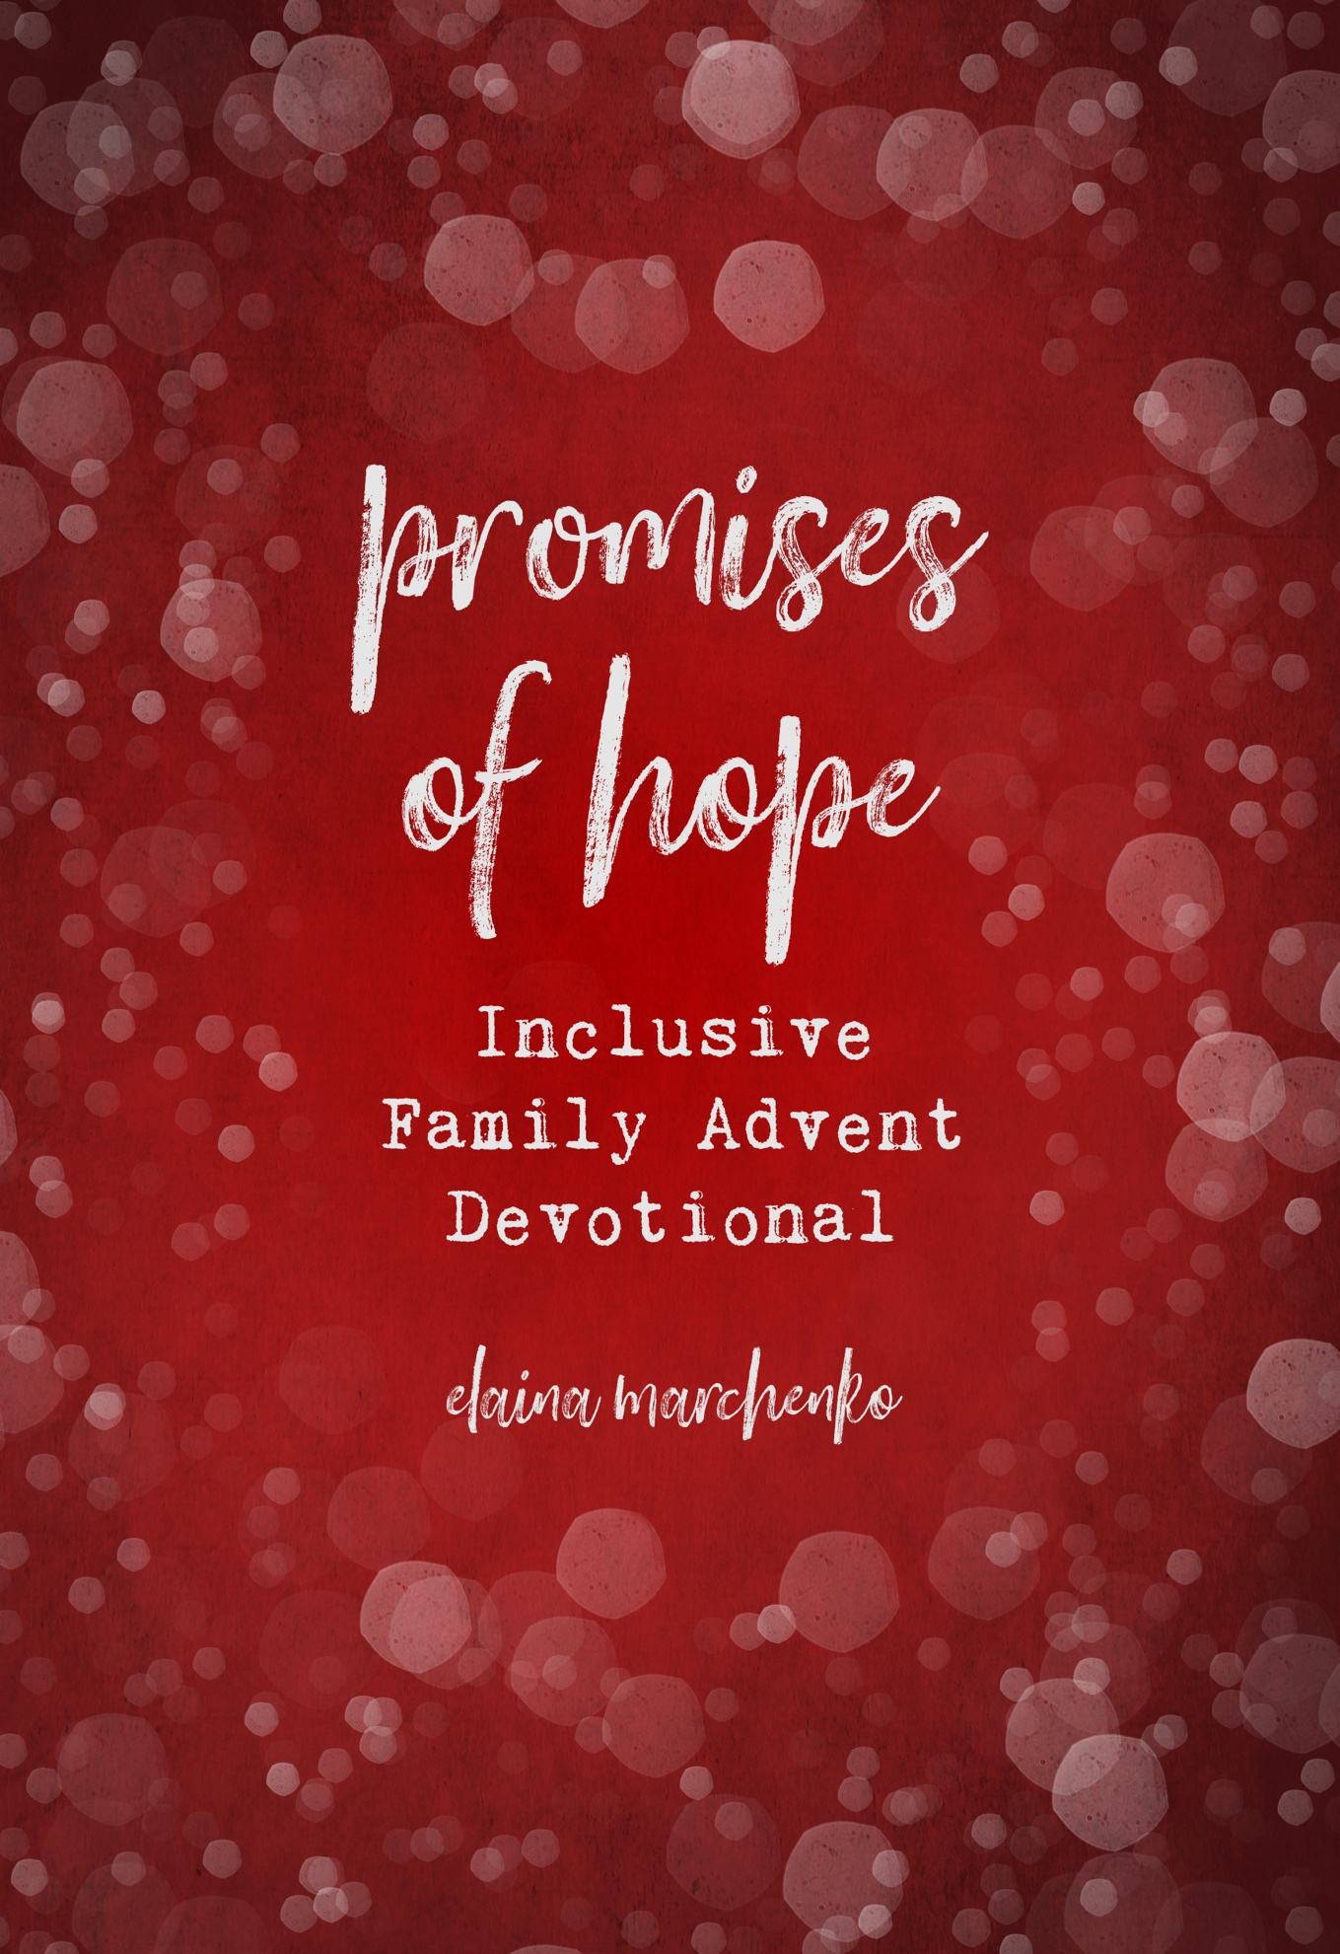

Week One
Hope from the Beginning
Read Genesis chapters 1-3

Devotional

In the beginning, God created the heavens and the Earth, and everything else in between, and even beyond! He created all things, and all things he saw to be good. After the creation, he created creatures to bear his image—he created man, male and female he created them (Gen. 1:27). He put them in his beautiful garden, to eat of the fruit and care for the animals.
The LORD put them in this heavenly garden with only one restriction, to not eat of a certain tree in the garden, only one tree could they not enjoy. This restricted tree was the tree of the knowledge of good and evil (Gen. 2:17). One day, the woman was tempted by a serpent to take a bite of a fruit from the knowledge and evil, and she convinced her husband to do the same. Once they ate, they realized they were naked and felt ashamed, and when they heard God coming, they hid from him out of shame for their disobedience.
Of course, they could not truly hide from God, and so God cursed the serpent for his evil saying,
"I will put enmity between you and the woman, and between your offspring and her offspring; he shall bruise your head, and you shall bruise his heel.”
The Lord tells of the future strife between humans and evil, but did you notice how it ends? God says that the offspring of the woman will bruise the head of the serpent, while the serpent bruises the heel. But what this ending tells us is that eternal strife is not the end! The offspring of the woman will bruise the head of the serpent, Jesus will overcome evil, and he already has. Amidst the turning point of the fall, a time when things went from sunny and giggly, to death, there is still a hopeful promise from the LORD, that this is not how things will remain. Praise the LORD for the hopeful promise made in the garden that day.

Scripture Memory Verse
"I will put enmity between you and the woman, and between your offspring and her offspring; he shall bruise your head, and you shall bruise his heel.” (Genesis 3:15)

Activities
- Recreate garden of Eden with playdough (or whatever else you have on hand)
- For kids who prefer auditory activities over tangible ones (or both!) here are some kids Christian Christmas music albums:
Just for the kids:
https://open.spotify.com/album/0BRAZ00fRF3RhEXE09GIaF?si=AQtVJLBhSDm0Wouk1cA-qw
https://open.spotify.com/album/63co4h84iEZl55Z6DFxpZ0?si=b3KQIhPVRl-npDLzGycSRw
https://open.spotify.com/album/5cAzMNwlrhXmi4vmcQjhCo?si=U4r8ORnDQ22JbJjHLTM1Bg

For the whole family:
https://open.spotify.com/album/6EDs538SIog94mGW1CTdyW?si=JdnAVQ_oRqmNbptDn6su_g
https://open.spotify.com/album/7yk2o4V19GtJPfbqkQcCb5?si=E9to8XkHR0ieQw4pKolSnA

Week Two
Hope throughout History

Read Ruth 2:19-20, 3:9-13, 4:9-11, 13-22

Devotional
The story of Ruth in the Bible takes place in a very small book in the Old Testament, with only four chapters. This book follows the story of Ruth, a young widow, who follows her mother-in-law, who has also lost her husband, back to her homeland of Bethlehem. They return in need of everything, since the men who had provided for them had all died. Ruth begins to collect leftover grain on the outskirts of a nearby grain field, which happens to belong to her distant relative, Boaz. Boaz shows her great kindness and gives her way more grain than her and Naomi need. Eventually, Ruth asks Boaz to marry her and to be her kinsman redeemer.
Do you know what a Kinsman redeemer is? This is when a distant relative takes care of family members who find themselves without their usual providers, the men of the family, like the situation Ruth and Naomi find themselves in. Boaz agrees to take care of them, and finally Ruth and Boaz marry and have a son.
Now, you may be wondering, what does this story have to do with a hopeful promise? Well, do you remember the promise God made with Eve in Genesis? When he said that an offspring of Eve will crush the serpent’s head? And do you remember how that means that a son from the line of Eve will defeat sin and death, once and for all? Well, it is also said in many places in the OT that this son of Eve who would crush sin and death, would be from the line of David. And guess what? Ruth and Boaz have a son named Obed, who becomes the father of Jesse, who becomes the father of David, who eventually leads to Jesus Christ.
This tiny little story in the Old Testament, that many might thing is not very important, shows the fruit of God’s promises of hope. God keeps his promises and uses broken people to do it. How incredible it is that God is a faithful God and keeps promises of hope!

Scripture Memory Verse
“May he be blessed by the LORD, whose kindness has not forsaken the living or the dead!”
(Ruth 2:20b)

Activities
- Put on a play of the short story of Ruth, reenacting the gleaning and the other events that take place in these four short chapters
- Find a good cookie recipe, talk about flour and grain, and tie these ingredients to the story of Ruth

Week Three
Hope for the Future

Read Isaiah 60, if the whole chapter is too long, read verses 1-3 and 19-22.]

Devotional
Isaiah chapter 60 is titled, The Glory of Zion. Now you are probably wondering, What is Zion? In this context, Zion refers to the people of God, like often the term Israel does. This chapter describes how the LORD will restore his people, and what it will be like in the future. It is a chapter of hopeful promising from God, and we know we can believe in this promise because of the other promises we have already seen come true! The Advent season is a great time to reflect on all the promises that our LORD has kept, and all of the ones he is still yet to fulfill! Discuss some of the promises God has fulfilled already in our lives. Then, discuss what ones he will fulfill in the future.
In this chapter, and in many other chapters within the prophetic books of the Old Testament, we find beautiful promises of what the LORD will do when he restores the world and her people. But let’s first remember why we need restoration, in the first place. When sin entered our world through the sin of Adam and Eve, the world was broken. The way God designed our world, with all of its beauty and peace, was broken. That is why we suffer now, why our favorite toys break or the people you love sometimes hurt your feelings or disappoint you.
Sin broke our world, and chapters like Isaiah 60 tell us more about God’s plan to fix it. The plan was always to restore creation. We were never meant to stay in this messy, broken, and sinful world. Christmas is not only a time to remember what Jesus has already done for us, but to also remember what we are waiting for. The theme of hopeful promise includes the crucial word hope. Hope is waiting for something you know will come, hope helps us live now as we anticipate the good to come.

Scripture Memory Verse
“Arise, shine, for your light has come, and the glory of the LORD has risen upon you.”
(Isaiah 60:1)

Activities
- Build gingerbread houses, with walls of ‘salvation’ and ‘praise’ like it says in the chapter
- Do an art project to recreate this heavenly city to come, using imagery from the chapter
- Plant something! This can be as easy as an indoor herb for the holidays. Discuss how God is our gardener who loves and tends to us, and who will one day let us be as beautiful as we were always meant to be. “They are the shoot I have planted, the work of my hands, for the display of my splendor” (Isa. 60 v.22b)
- Listen to “We Will Feast in the House of Zion” by Sandra McCracken (who also has great Christmas music)

Week Four
Hope in a Person
Read Luke 1:46-56
Devotional
Mary, the soon-to-be mother of Jesus, sings this song of praise to the LORD after the angel Gabriel comes to her and tells her of what will come to be. Mary’s song praising the LORD is one full of reversals, of making low what was once high, and emptying the full. Mary praises the LORD for being chosen to serve as the mother of Jesus, an incredible honor to serve the LORD her God in this special and particular way.
Mary also remembers the promises that the LORD made with the generations before her, calling on the covenant with Abraham. Do you remember what the covenant with Abraham said? Here it is if you need the reminder:
"The word of the LORD came to Abram in a vision: ‘Fear not, Abram, I am your shield, your reward shall be very great’...’Look toward the heaven, and number the stars, if you are able to number them…so shall your offspring be’... ‘To your offspring I will give this land,’" (Genesis 15:1, 5,1 8).
God made a covenant with Abraham, one that promised plentiful offspring, the promised land, and the presence of the LORD as protection. This promise lived on even until Mary, as she acknowledges in her song. She recognizes God’s faithful care for her and her people in the past, and how that promises God’s care to continue into the future. She bases her song on a promise of hope that was fulfilled for Abraham and the Israelites, and how this same promise of hope is being made to her now as God promises to bring Jesus through her in a miraculous birth, to save the world.
Scripture Memory Verse
“And blessed is she who believed that there would be a fulfillment of what was spoken to her from the Lord.” (Luke 1:45)
Activities
- Sand project. Either just play with sand, filling, dumping, and refilling, or find a more creative sand project. Whatever the activity is, let is represent a great reversal.
- Use water in the tub to make things full and empty, discuss the reversal that the Kingdom of God brings

Christmas Day Reading
A day to remember hope and have hope for all to come!

Read Luke 2:1-21

Scripture Memory Verse
“And the shepherds returned, glorifying and praising God for all they had heard and seen, as it had been told them.” (Luke 2:20)

Activities
- Put on a show (puppets, or other figurines) of the birth story of Jesus
TIP: use a nativity set you have either old or out for decoration to demonstrate the birth story of Jesus, if the set is
- Make star-shaped cookies and discuss the shepherds as the first disciples! They were the first to share the Good News of Jesus.
- Play with lights! Either by going to see beautiful holiday lights, or by using lights at home to go from darkness to light, feel free to get creative! You can use flashlights or night-lights or whatever else you have on hand. Discuss Biblical themes of Light, and God shining Light into dark places (John 1:5)

